**E-Stock Market Implementation**

GitHub Repository Path:

<https://github.com/prosenjit005/E-Stock-Market-Project>

Contents

Implementation Flow 1

Starting the Applications 1

Check the results in Postman and DBs 4

# Implementation Flow

Projects:

company-api: This will handle all company related CRUD operations. Also, a Kafka Producer to sync MongoDB.

stock-api: This will handle all stocks related CRUD operations. Also, a Kafka Producer to sync MongoDB.

stockmarket-eureka-server-api: Eureka Discovery server for the application.

stockmarket-gateway-api: Spring Cloud gateway for the application.

kafka-consumer-mongodb: Kafka Consumer to perform CRUD in the MongoDB.

On any CRUD operation first the request will go to the API and the MySQL DB will be updated. Then via Kafka, Mongo DB will also be in sync for the CRUD operations. The calls from Company to Stocks and vice versa is done via Feign Client implementation.

# Starting the Applications

Start the Zookeeper and Kafka:

Local Path: C:\Prosenjit\IT_Softwares\Kafka\kafka\bin\windows

start zookeeper.start bat (Default port = 2181)

zookeeper-server-start.bat ./../../config/zookeeper.properties

start Kafka server (Default port = 9092)

kafka-server-start.bat ./../../config/server.properties

Zookeeper:

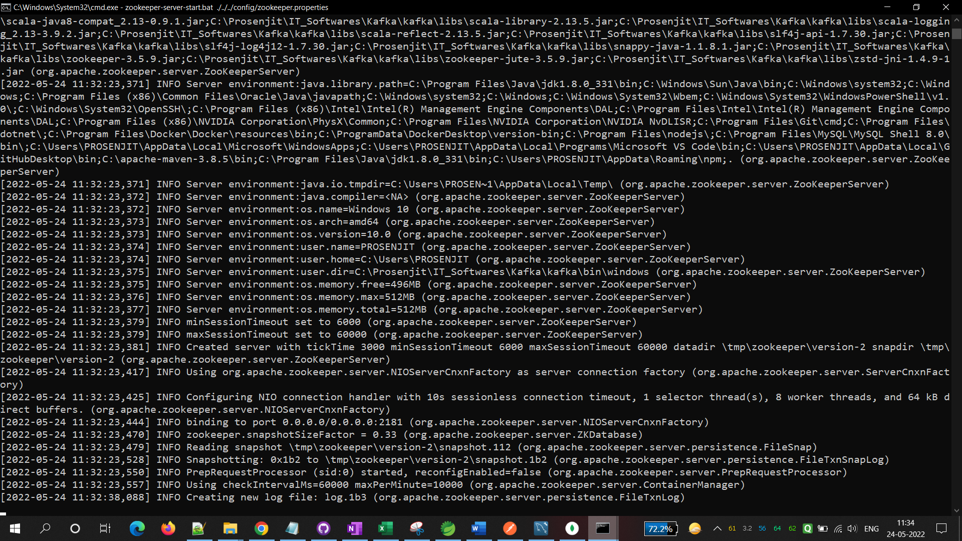

Kafka:

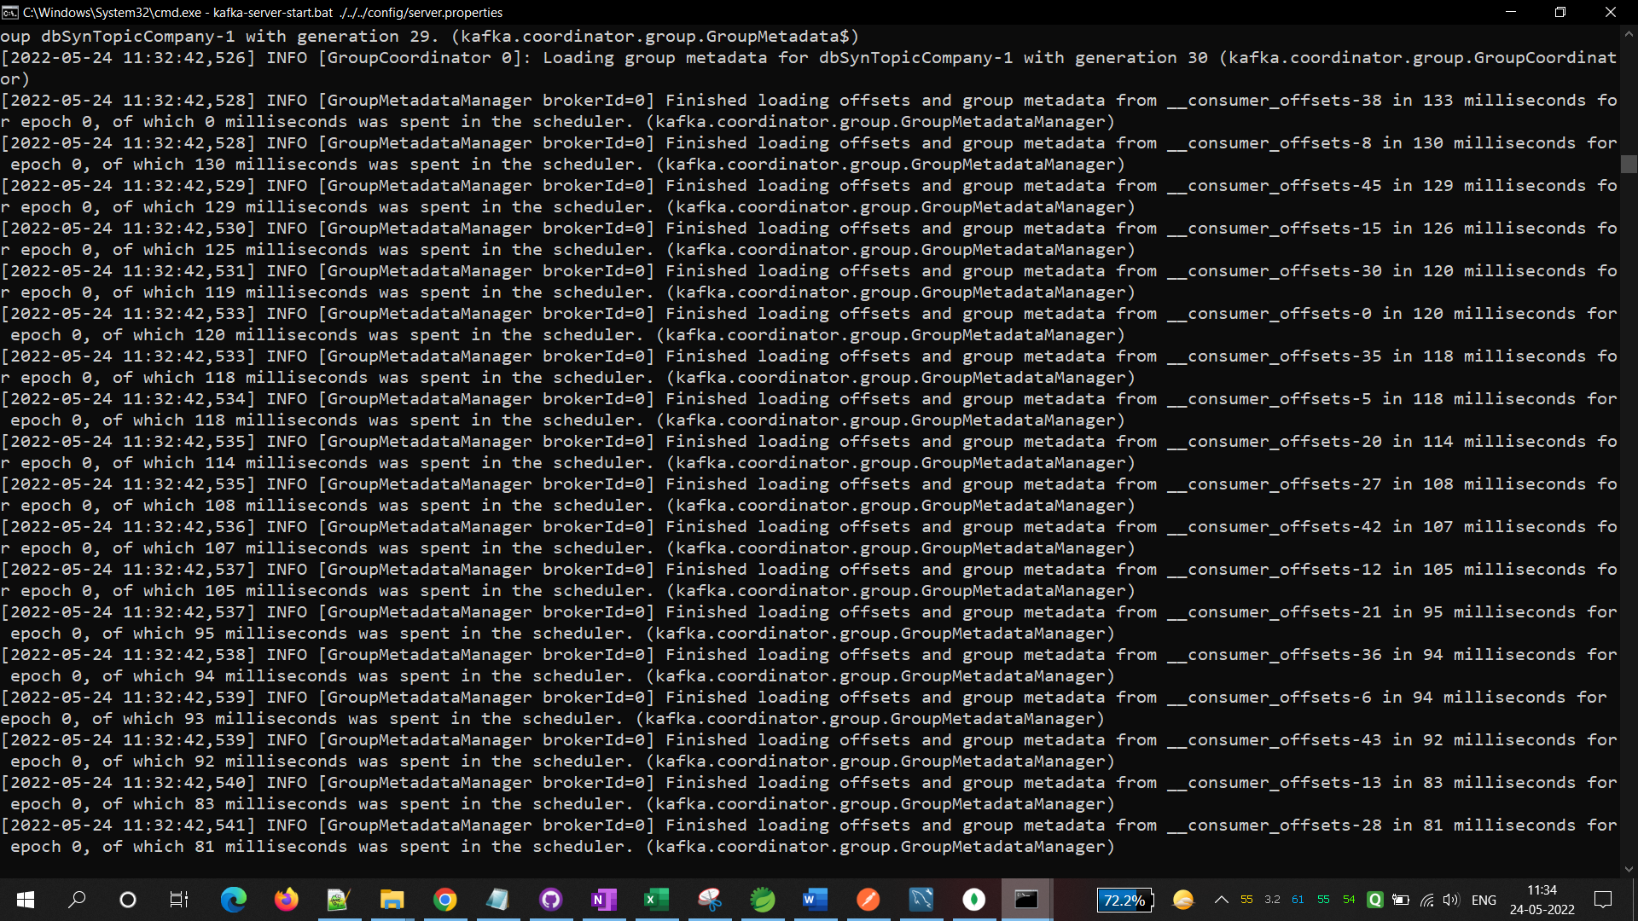

Then start the 4 applications in STS:

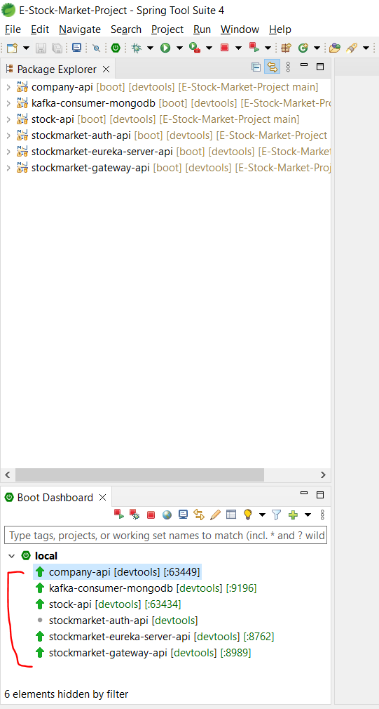

Start both MongoDB Compass and MySQL Workbench

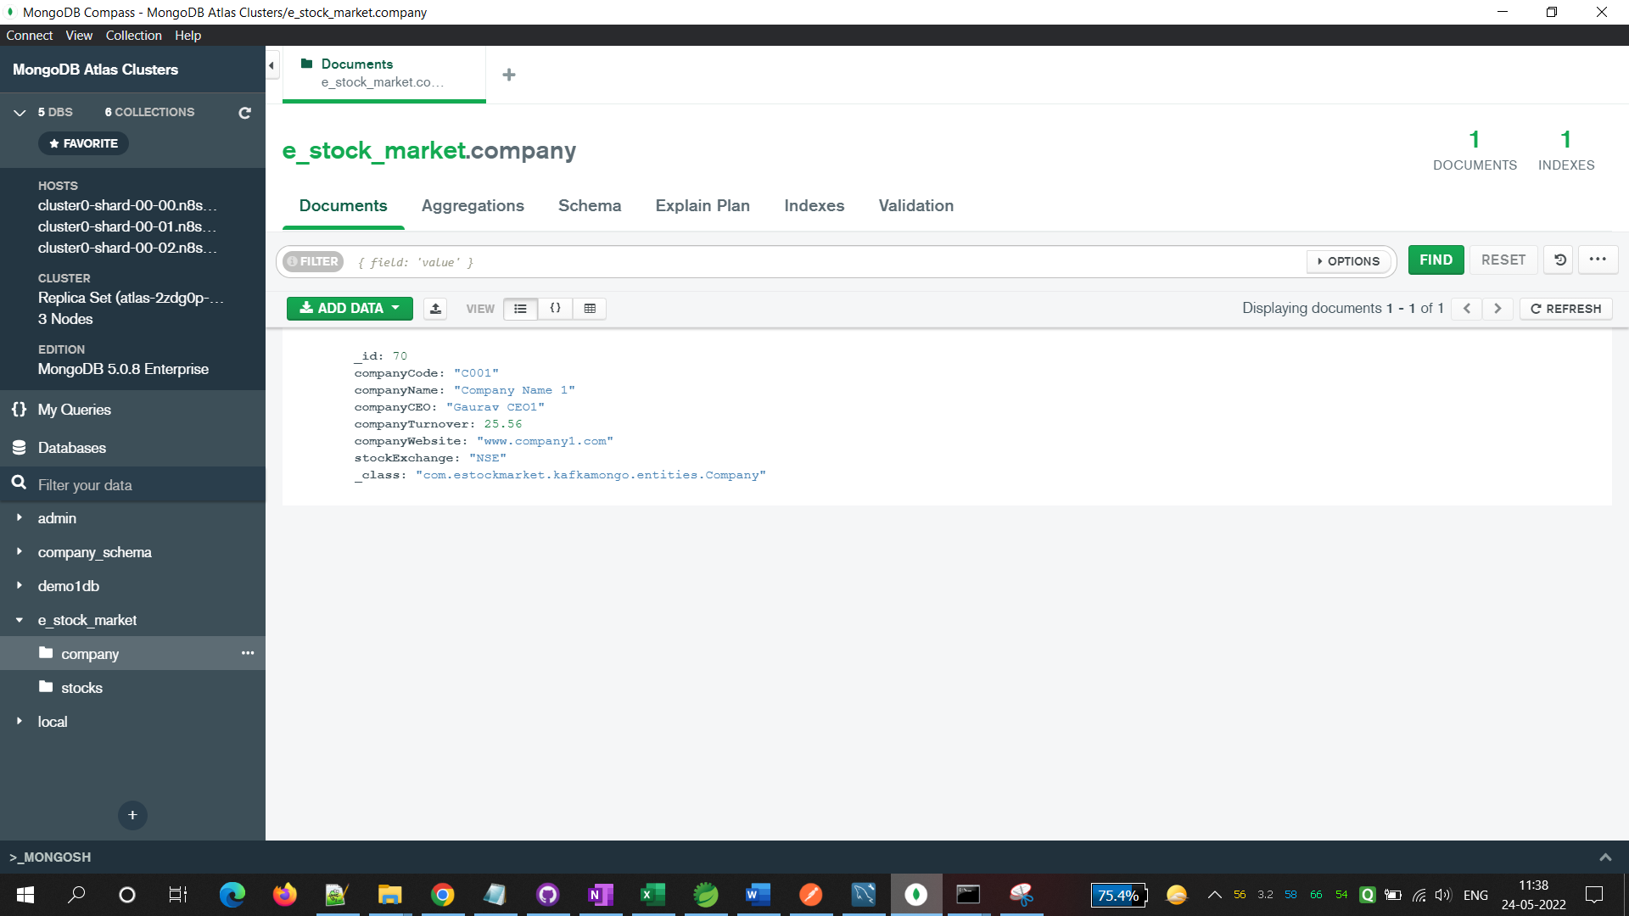

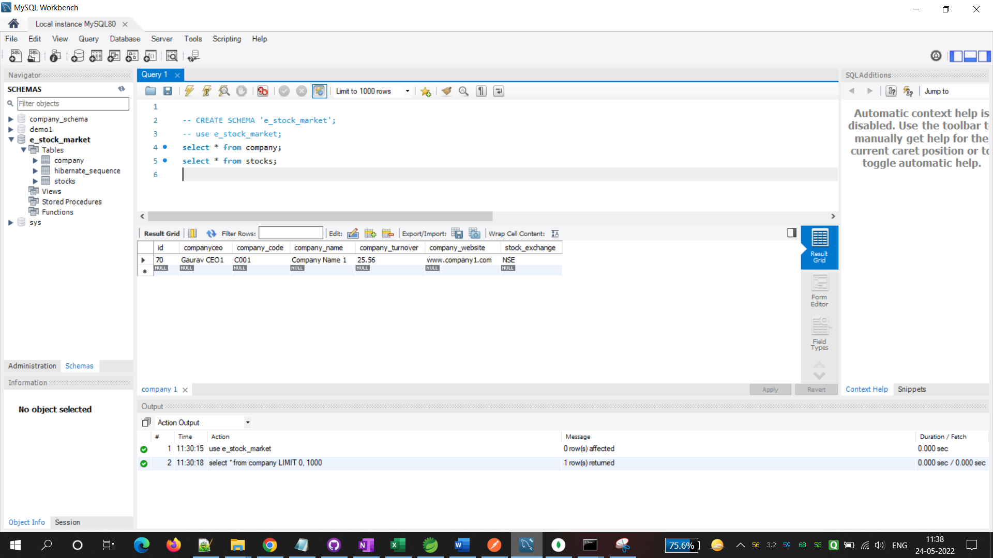

# Check the results in Postman and DBs

Test Endpoint:

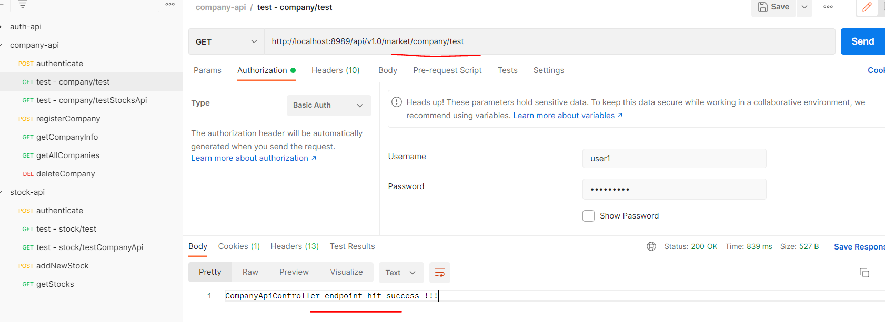

Stocks API hit from Company API:

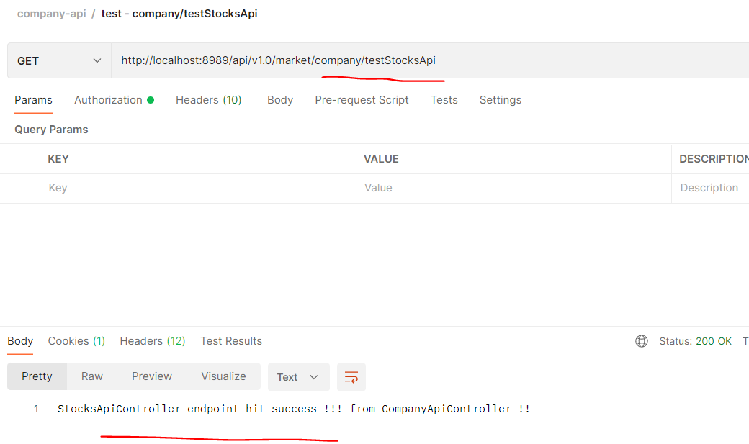

Endpoint: api/v1.0/market/company/register

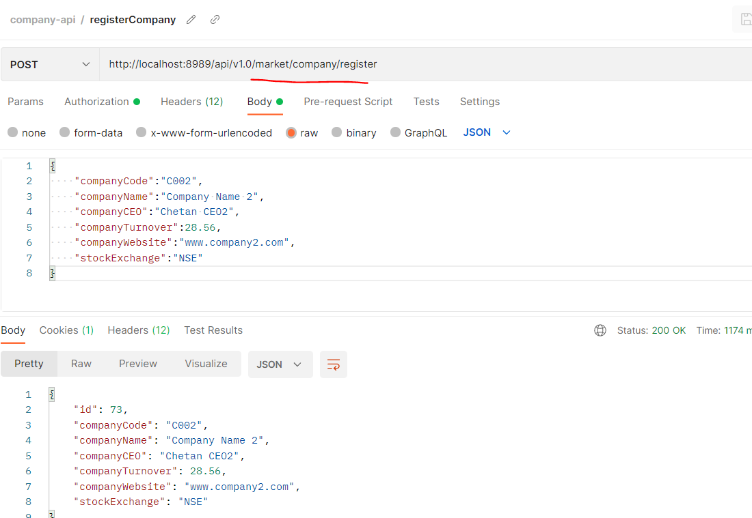

Check the DBs for the above operation:

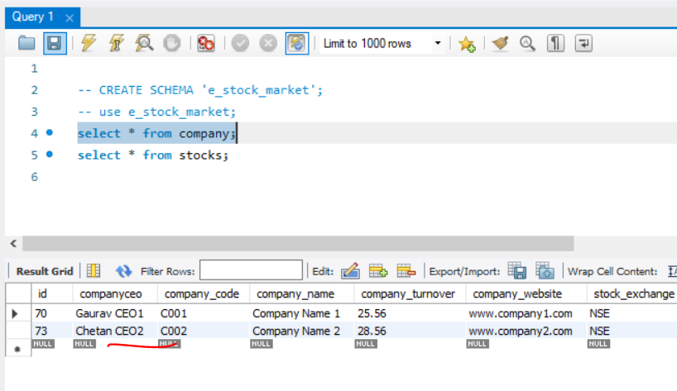

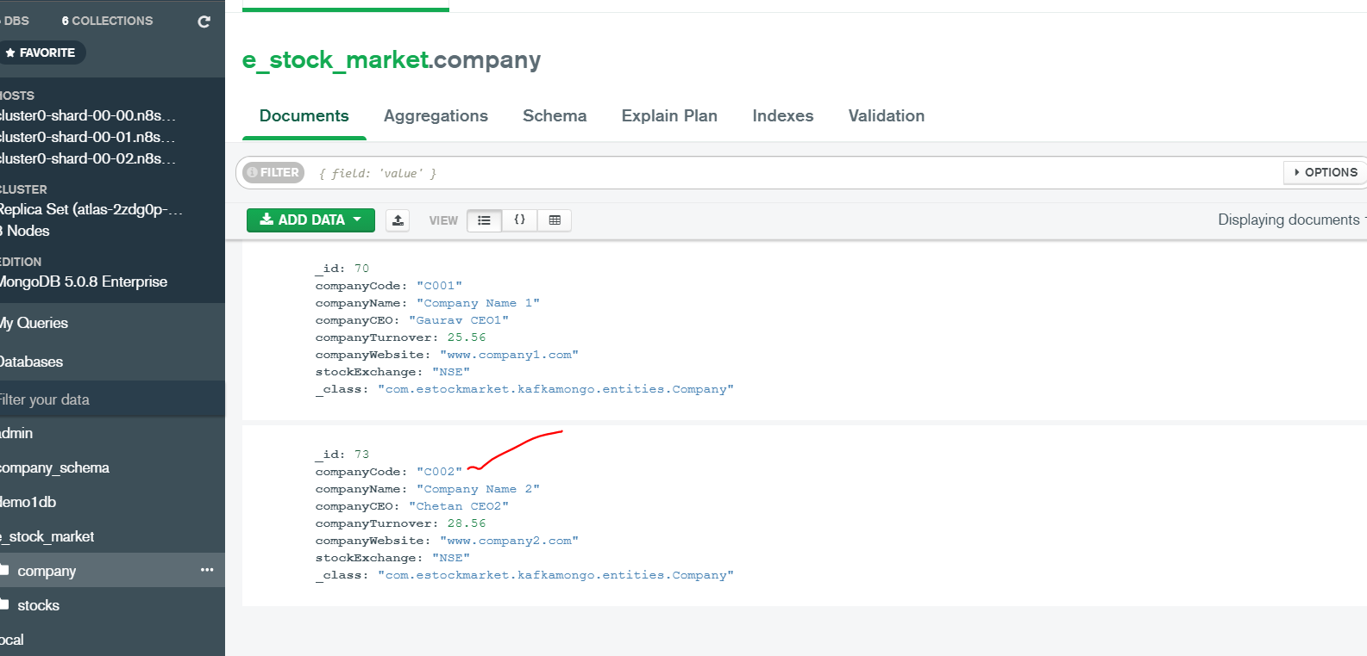

Endpoint: api/v1.0/market/stock/add/C002

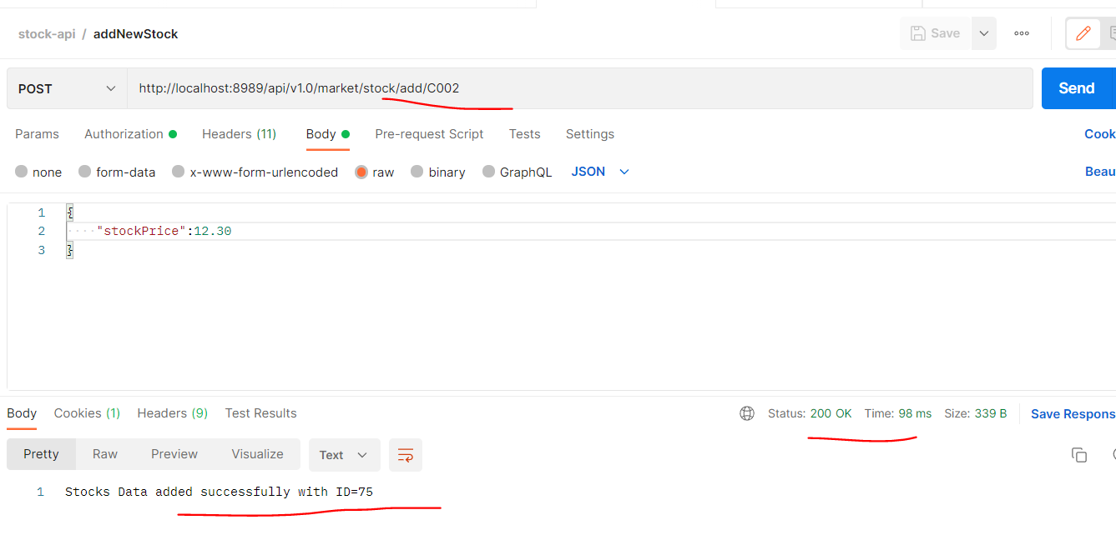

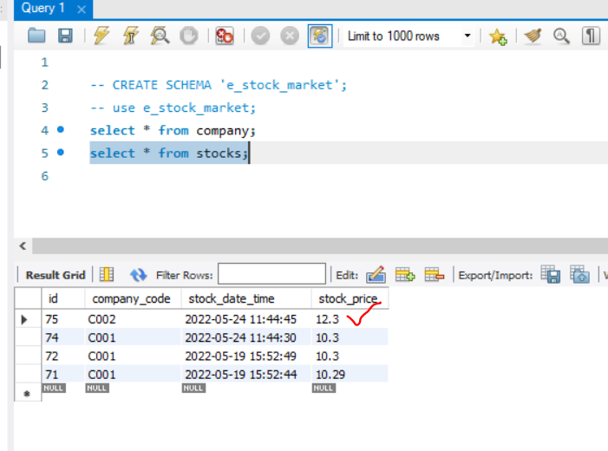

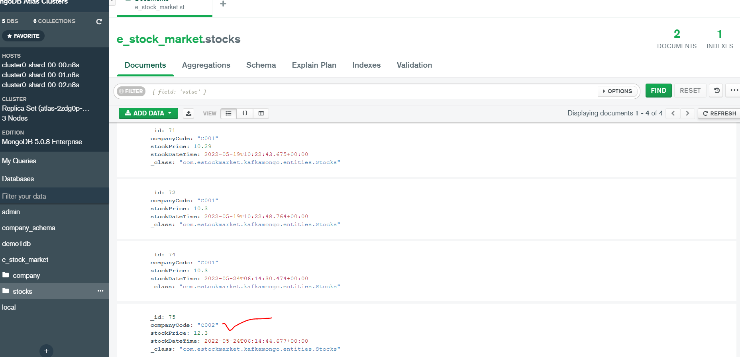

All Working Fine! Both DBs are in Sync for all the operations.